**Test Case 1:**  
Step 1: Go to <https://the-internet.herokuapp.com/windows>  
Step 2: Click on the ‘Click Here’ button. This opens a new Tab.  
Step 3: Go to the new tab and verify that the URL has the text ‘/windows/new’ and the webpage has the text ‘New Window’

**Test Case 2:**  
Step 1: Go to <https://alapanme.github.io/testing-cypress.html>  
Step 2: Click on the ‘Try it’ button.  
Step 3: A new window would be opened. Verify that the header text in the new window is ‘Welcome to the-internet’.

|  |  |
| --- | --- |
| 1 2 3 4 5 6 7 8 9 10 11 12 13 14 15 16 17 18 19 20 21 22 23 24 25 | describe('Example to demonstrate the handling of new browser windows in cypress', () => {      it('Handling new Browser Tab', function () {         cy.visit('https://the-internet.herokuapp.com/windows')         cy.get('.example > a').invoke('removeAttr', 'target').click()         cy.url()             .should('include', '/windows/new')         cy.get('h3')             .should('have.text', 'New Window')     })      it('Handling new Browser Window', function () {         cy.visit('https://alapanme.github.io/testing-cypress.html')         cy.window().then((win) => {             cy.stub(win, 'open', url => {                 win.location.href = 'https://the-internet.herokuapp.com/';             }).as("popup")         })         cy.get('button').click()         cy.get('@popup')             .should("be.called")         cy.get('h1')             .should('have.text', 'Welcome to the-internet')     }) }) |

[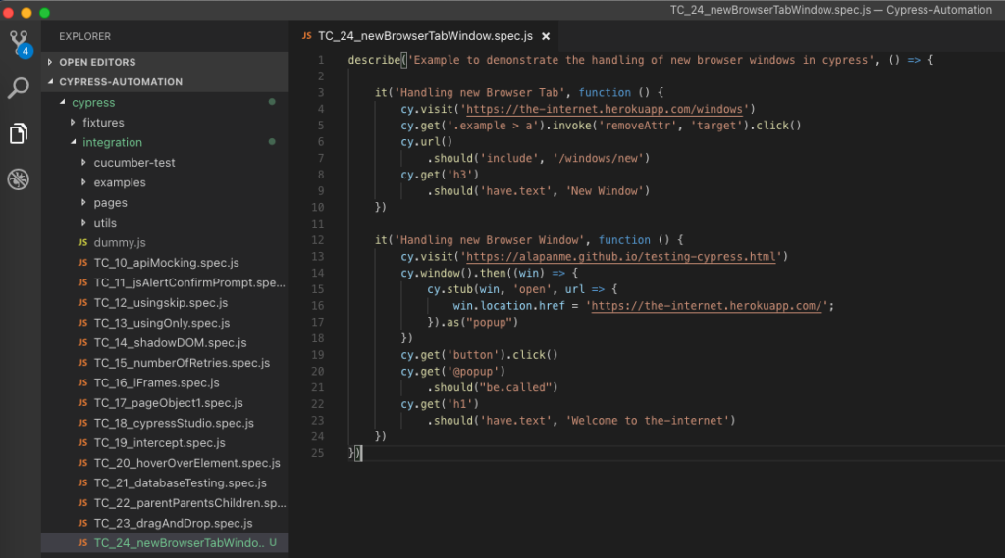](https://testersdock.b-cdn.net/wp-content/uploads/2021/08/cypress-new-window-and-tabs-test-script.png)

|  |  |
| --- | --- |
| 1 2 3 4 5 6 7 8 | it('Handling new Browser Tab', function() {   cy.visit('https://the-internet.herokuapp.com/windows')   cy.get('.example > a').invoke('removeAttr', 'target').click()   cy.url()     .should('include', '/windows/new')   cy.get('h3')     .should('have.text', 'New Window') }) |

Since cypress doesn’t allow the opening of a new browser tab, the workaround in such cases is to remove the attribute – **target=’_blank’**. Now when we click the ‘Click Here’ button, instead of a new tab, the webpage is opened in the current tab. And then when the webpage is loaded, we are validating that the URL has the text ‘/windows/new’ and the webpage has the text ‘new Window’.

|  |  |
| --- | --- |
| 1 2 3 4 5 6 7 8 9 10 11 12 13 | it('Handling new Browser Window', function() {   cy.visit('https://alapanme.github.io/testing-cypress.html')   cy.window().then((win) => {     cy.stub(win, 'open', url => {       win.location.href = 'https://the-internet.herokuapp.com/';     }).as("popup")   })   cy.get('button').click()   cy.get('@popup')     .should("be.called")   cy.get('h1')     .should('have.text', 'Welcome to the-internet') }) |

In this test, our goal is to read the contents of the webpage that is opened after clicking the ‘Try it’ button. The webpage is opened in a new browser window.

[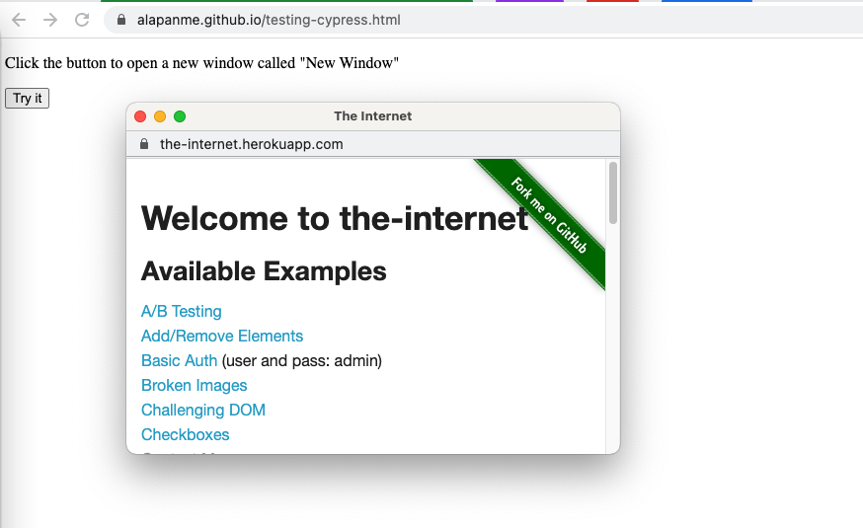](https://testersdock.b-cdn.net/wp-content/uploads/2021/08/new-browser-window.png)

First, we get the Window object and then we replace the **window.open(url, target)** function with our own arrow function. Then we change the window location **win.location.href** to be the same as the popup URL and then we create an alias for the same as **popup**, so that we can refer to it later using **@popup**. Then we click the ‘Try it’ button, which triggers javascript’s **window.open()** call. To make sure that the window.open function call is triggered we are writing an assertion as **cy.get(‘@popup’).should(“be.called”)**. Then we are continuing the testing for the new “popup tab” inside the same tab and asserting that the webpage has the text ‘Welcome to the-internet’.

After Execution, We should see a ‘PASS’.

[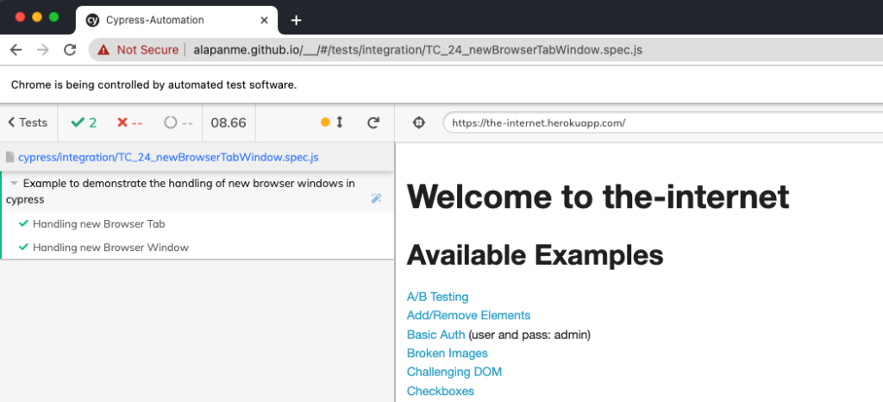](https://testersdock.b-cdn.net/wp-content/uploads/2021/08/cypress-new-browser-window-tab-test-script-execution.png)

Do check out 🙂